HUNGARIAN

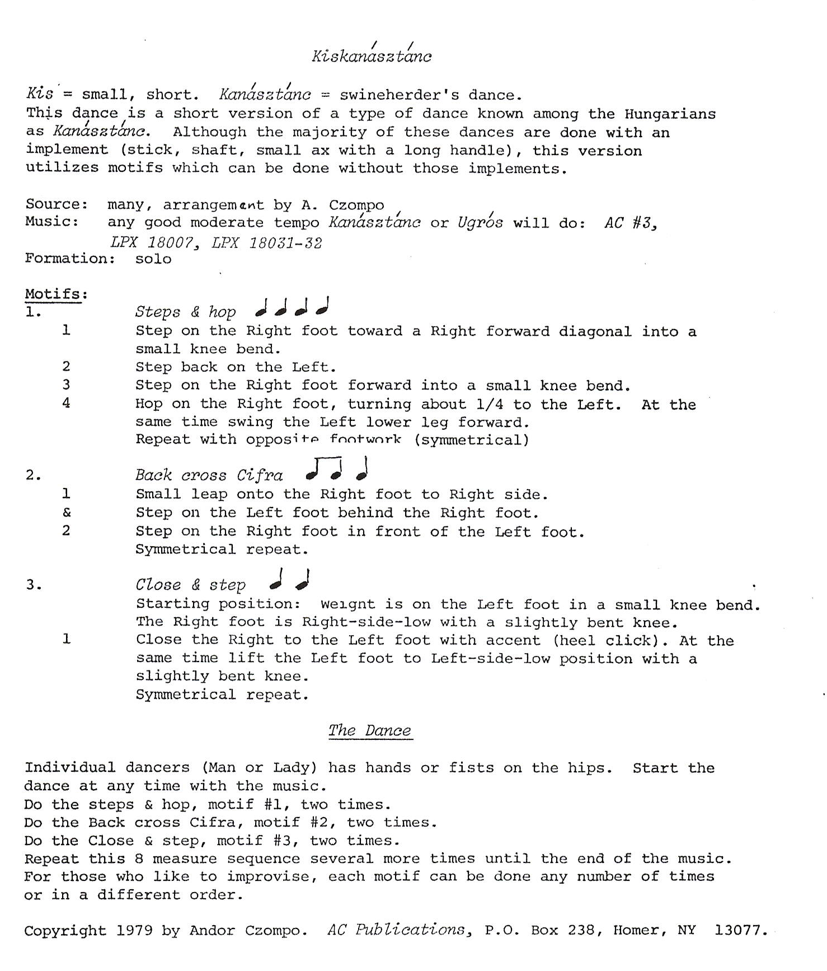

Bagi Karikázó

Hungary

Pronunciation: Bah-gee Kah-ree-kah-zoh.

*Type:* A Hungarian dance for girls from the village of Bag.

*Source*: Andor Czompo, 1983

*Formation*: Closed circle with hands joined and down (V position)

**MOTIFS:**

Counts *1) Progressive Csárdás*

1 Step R foot diagonally R FWD

2 Step L foot beside R

3-4 Step R foot diagonally R FWD

5-6 Step L foot diagonally L FWD

Repeat with same footwork

*2) Csárdás and Sways*

1 Step R foot to R side

2 Step L foot beside R

3-4 Step R foot to R side ( feet stay apart)

5-6 Sway - change weight to L foot

7-8 Sway to R foot

9-12 Repeat counts 1-4, with opposite footwork and direction (small steps)

Repeat the same way

*3) Closed Rida*

1 Step R foot in front of L with small knee bend

2 Step L to L side

Repeat the same way

*4) Váltó (directional change)*

1-2 Step R foot in front of L

3-4 Step L foot to L side

5-6 Step R foot to R side

*5) Stamping Runs*

1-3 3 running steps in place - R, L, R (Q, Q, S)

The runs are done with slight stamps.

Repeat with opposite footwork.

*6) Bukós (single)* ( Refered to as “Whoof”)

1 Small step on R foot to R side

2 Step L foot beside R

3-4 Step into a small 2nd position (stride) with a small knee bend and hold

Repeat with opposite footwork and direction.

*7) Bukós (double)* ( refered to as “Double Whoof”)

1-3 Repeat Bukós (single) MOTIF 6, counts 1-3

4 Straighten knees

5-6 Bend knees and hold.

Repeat with opposite footwork and direction.

Measure **MELODY 1**

1-3 Introduction

4-18 Do Progressive Csárdás, MOTIF 1 in LOD - 10 times

**MELODY 2**

1-18 Do Csárdás and Sways, MOTIF 2 - 6 times

**MELODY 3**

1-6 Do Closed Rida, MOTIF 3 - 12 times

7-12 Do Váltó (Directional change) Motif 4 and 9 Closed Rida, MOTIF 3

13-18 Repeat measures 7-12 with opposite footwork and direction

*FAST PART*

**MELODY 1**

1-12 Do the Stamping Runs, MOTIF 5 - 12 times

In the mean time, tighten the circle and change the hand holds by raising the arms FWD and high and lowering them in the back to a “‘back-basket’ hold”

**MELODY 2**

1-6 Do Bukós (single), MOTIF 6 - 6 times

7-12 Do Bukós (double), MOTIF 7 - 4 times

**MELODY 3**

1-18 Same as SLOW PART: MELODY 3. During the last three measures change the Rida to running steps in place with stamping and face the center. Do a sharp close on the last count.

Korcsárdás

Hungary

Korcsárdás, based on authentic folk material, was arranged by Andor Czompo for recreational folk dancing in the United States.

Formation: Any number of couples in a series of small circles scattered around the room, W to the R of M. Have at least six couples in a circle for comfort.

DANCE: 2/4 DESCRIPTION

**Part I**

All assume back basket hold.

Downbeat Rida: moving to the L, step on the R foot across in front of L foot with both knees bent (ct 1). Step to the L on the ball of the L foot with a straight knee (ct &). Do the down-up pattern (Downbeat Rida) for a total of 11 times. On the 12th count, step on R foot across, and swing L foot around close to the ground, from the back to the front. This puts you in a position to change directions. Now do the Downbeat Rida step, moving to the R and crossing first with the L foot. Continue moving for a total of 11 counts. Finish on the L foot on count 12.

**Part II**

Take shoulder-waist position and do three Csárdás steps in the following manner:

To R: Step to the R side on R foot, close L foot to R Foot, step to the R on the R, and bend R knee.

To L: Step to L side on L foot, close R foot to L, step to side on L foot, bend L knee.

To R: Same as above.

Still in shoulder-waist position, change position so that R hips are adjacent. Walk CW around in place with 8 walking steps, starting with the L foot. Finish with 3 stamps in place, L, R, L, facing partner.

Repeat 8 walks and 3 stamps moving CCW with L hips adjacent, and end facing partner. Do NOT take weight on the last stamp with the R foot.

Downbeat Rida: Still in shoulder-waist position and starting with the R foot across in front of L foot, do six Rida steps moving CW. Before you complete the six Rida steps, open out the couple and resume the original back basket hold in the circle.

Repeat the entire dance from the beginning.

**PORTUGUES**

Malhao

(Portugal)

This couple dance is from Vila Nova de Gai a in northwest Portugal. There are at least 4 versions that Andy is aware of. This version was introduced by France, taught by Yves, Marianne Taylor and presented by Andy Taylor-Blenis

Pronunciation: mahl-YEOW (the l is all but silent)

Formation: Partners face each other in contra lines.

Steps: **Basic step:** Facing partner, step R back (ct 1); step L next to R (ct 2); step R fwd (ct 3); hold (ct 4). Arms swing easily down, back and up again. Can be done with opp ftwk and direction.

**Side steps:** 3 steps to own right (R-L-R) while facing to R (cts 1-2-3). Lift on R swiveling on R to face L (ct 4). Can be done with opp ftwk and directions.

Style: **Arms and Hands**. Arms for both M and W are raised in Part I and extended above shoulder height to each side, slightly ahead and palms facing out. When clapping hands, palms are flat, fingers spread and extended, and the clap is at face height.

METER: 4/4 PATTERN

Meas

One note **Introduction**. No action.

(The first R is difficult to respond to, so consider not going R only on the first time through the dance.)

**I. Two Lines Facing and Moving in Opposite Directions**

1 Dance Side Steps, starting to R to R. Arms for both M and W are raised and extended above shoulder height to each side, slightly ahead and palms facing out.

2 Dance Side Steps, starting to L to L.

3-8 Repeat measures 1-2 three times.

9 Facing ptr. Two steps R-L, touch R next to L.

**II. Backward and Forward**

1 Facing ptr, do the Basic Step R-L-R with arms swinging down and back.

2 Still facing ptr, step L-R-L in place while clapping hands on each step.

3-8 Repeat 1-2 three times.

**III Back and Turn**

1 Dance Basic Step R-L-R, with arms swinging down and back.

2 Turn right (CW) in place with 3 steps, L-R-L, begin with L crossing in front of R. Arms are held over the head in a graceful curve during the turn.

3-4 Basic step as in Figure II meas 1-2.

5-8 Repeat 1-4.

Sequence:

Repeat the entire dance. On the fifth repeat of the dance, there are only 8 measures in Figure I so OMIT measure 9.

Não Vás Ão Mar Tonho

Portugal

Portuguese dance from Nazaré.

Pronunciation: now VAHZH ow MAR TOHN-yoh

Music: Dances of Portugal

Rhythm: Mixed 2/4 and 3/4 meter

Formation: Circle of cpls with two cpls working together. Stand side-by-side with ptr, facing LOD, inside hands joined. W's free hand on hip; M's free hand behind the back.

Steps: Finger snaps are optional whenever appropriate.

**Vira:** Quick running steps beginning with either foot. Step R fwd (ct 1); step L fwd (ct &) ; step R fwd (ct 2) . Knees are bent, and steps are flat-footed. The Vira is simply three steps, but the first is accented even lower! The body is straight, but slightly relaxed on the Vira.

**Vira Cruzada:**

Meas 1-2: With 2 Vira steps (beg R) M1 and W2 ("first corners") move in to meet, L shoulders adjacent while "second corners" balance in place. (From this point, second corners will repeat movements of the first corners, but always two bars later.)

Meas 3-4: First corners, with 2 Vira steps, move back to place, pulling L shoulder back to end with R side slightly toward corner.

Meas 5-6: First corners cross to each other's place, passing face to face with L shoulder leading.

Meas 7-8: Back away to end with R shoulder toward ctr as before.

Meas 9-16: Repeat meas 1-8 to home places; on last 2 meas, second cpls must pass through ctr, efficiently as they have only 2 Vira steps for crossing.

METER: 2/4 & 3/4 PATTERN

Meas

**Introduction:** 3 meas plus 3 notes upbeat.



2/4 Meter **Walking in Circles**

1-4 All walk in LOD 8 steps beg L.

5-8 Continue walking, W in front of ptr, hands on hips - single file.

9-11 First M turns to ctr, L elbow toward L elbow of second M. His ptr follows him and second W follows her, with second M following her, M 1, W 1, W2, M2. All wheel CCW for 5 steps, turning away from ctr on the last step. (This resembles a L-hand star without hands!)

12-14 Wheel CW ® elbow in ctr) six steps, ending in starting positions.

3/4 meter **Transition 1**

15 Facing CCW, with R shoulders to ctr, step L to L, 2 steps in place R-L.

**Vira Cruzada**

1-16 Dance Vira Cruzada Step (see Steps above), ending in home places.

2/4 meter **Transition 2**

17 3 steps in place: R, L, R. All couples join inside hands and face LOD.

**Ending**

1-8 Retain ptr's hand and walk side by side for 16 steps as in Part I, bowing on last note.

Dance goes through 3 times followed by the Ending.

**VIRA DO SITIO**

Portuguese couple dance, 2 couples dancing together but you need 16 couples in a circle to make it work best.

Originally from Nazare

A circle of couples, in groups of two working together, men with backs to center,facing partner.

BARS (Hands up and forward)

PART I

1-8 All turn to right, moving around circle (M CW, women CCW using 8 turning

vira steps - 3 ½ turns) End with strong down step on L vira.

9-15 Return to place, moving left (M CCW, W CW using 7 turning vira steps – 3 ½ turns) to face partner.

16-17 Balance in place, L and R

18-19 Cross to partner's place, passing right shoulder, face to face (2 vira steps)

20-21 Balance again in partner's place

22-24 Cross to own place, 1 vira step, step on R – ct. 1 of bar 23 – and clap twice

(last count of bar 23, first of bar 24)

PART II

1-15 With L shoulders to center of group of 4, dance around CCW twice with 15 steps, beginning R, to end in place facing partner

16-24 As in Part I.

PART III

1-15 With R shoulders in, repeat Part II, but move CW, beginning with L foot

PART IV

1-8 As in bars 1-8 of “Nao Vas ao Mar, Tonho”, Part II, dance crossing over to

diagonal place (M # 1, W#2, then M#2, W#1)

9-24 Turning away from original couple, dance vira cruzada over and back with the

next couple, to end as in Bar 8

25-33 Dance vira cruzada with original couple, to end in original places and clap twice as in bars 23-24 of Part I.!

Repeat from the beginning.

Learned from Madelynne Greene, who learned this dance in Portugal.

**ROMANIAN**

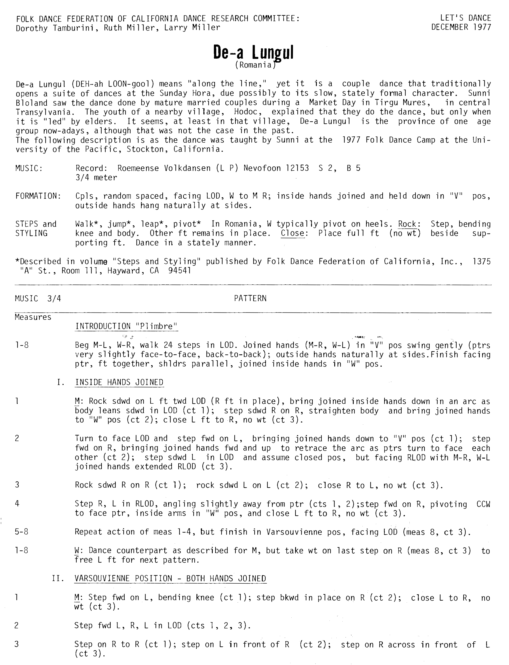

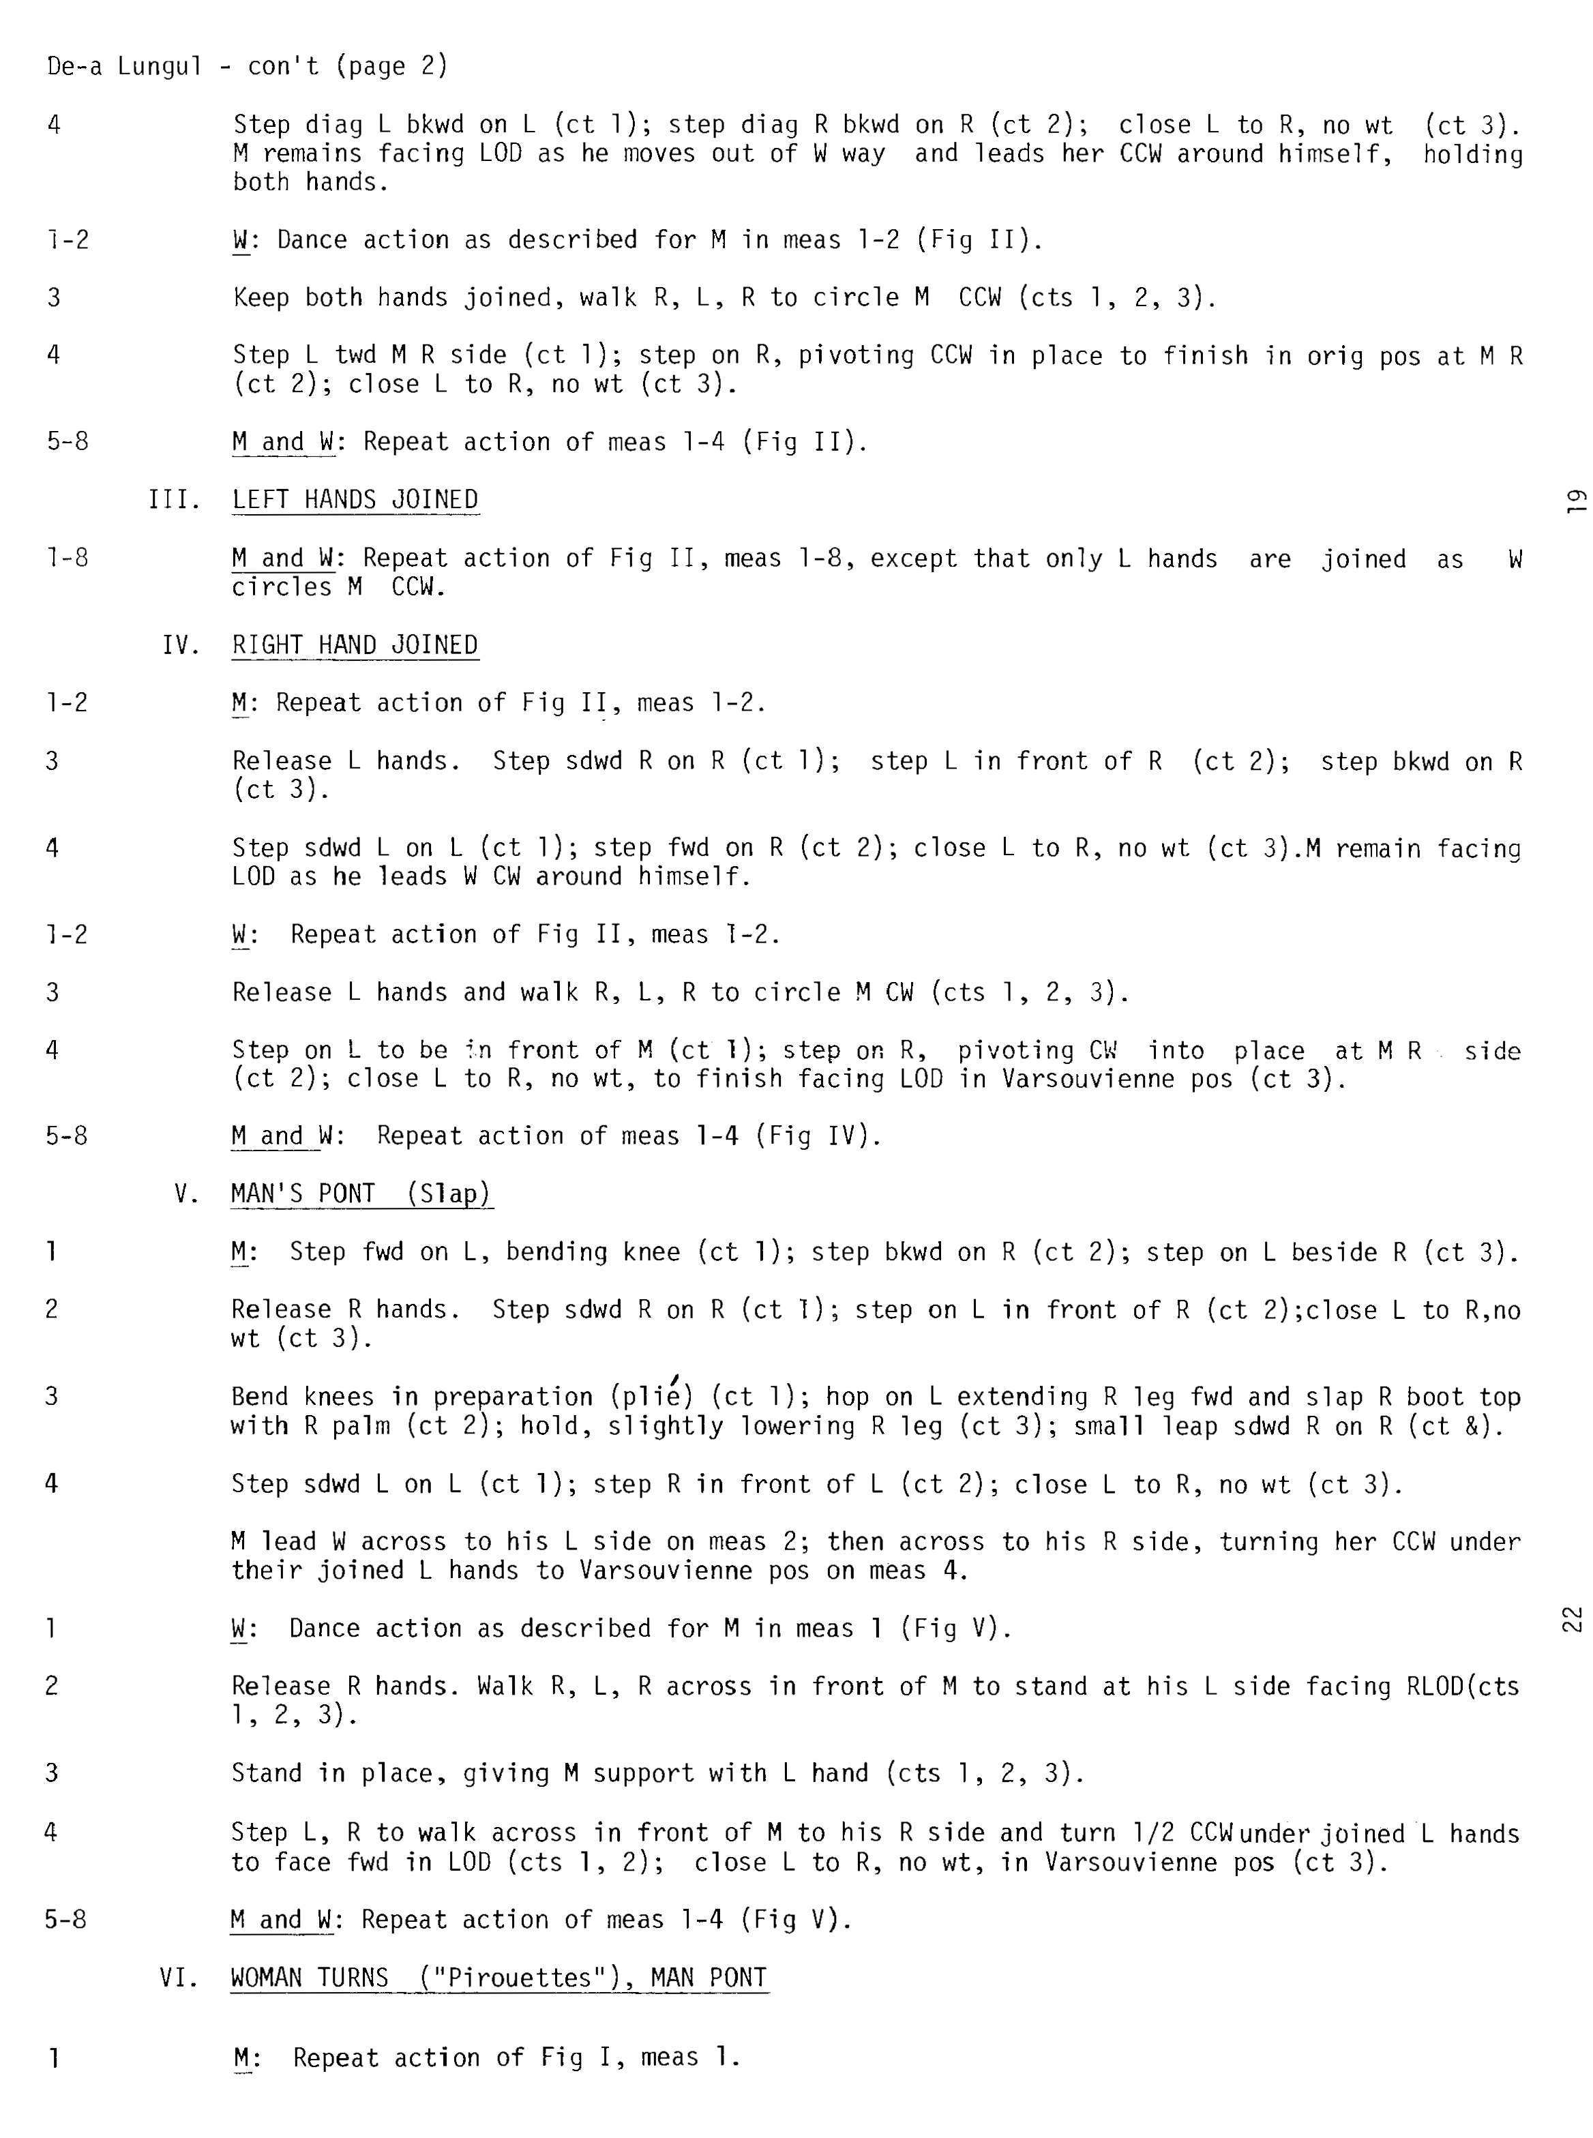

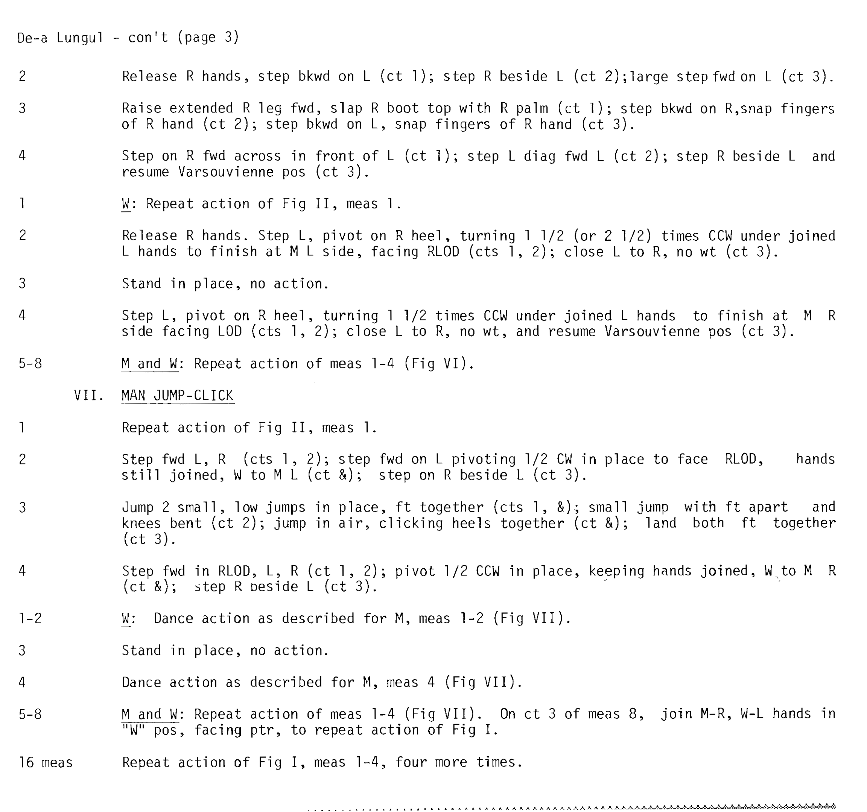

**Contras**

**Mountain Promenade**

2 couple dance done in longways set. Music; any jigs.

Active couple cross over (improper) & face down

Counts Actions

1-16 1s Balance and swing below, men leave woman on the R

face in,

17-24 R hand star

25-32 Circle back to the R. 1s open up to a line of 4

33-40 Down for 4, ends California twirl (men walk R raising R hand over woman’s head to switch places and face up)

41-48 Walk up for 4, 2s gate the 1s (cast off)(2s back up)

49-64 (Men fall back a little to bring ladies in for) Ladies Chain over and back.

Having progressed, 1s face down

**Chorus Jig**

Danced to the tune by the same name which is a reel not a jig.

Triple minor; 3 couple dance in longways set, take Hands 6 from the top.

Bar Actions

1-16 Active couple cast down the outside of the set, turn in towards partner and come back up

17-24 Active couples down the center for 6, turn and come back up for 6, cast off, the 2’s gate them out and down

25-32 Actives dance Contra Corners;

R to your partner (pass by or ½ turn), L to your 1st corner, R to your partner in the center, L to your 2nd corner

33-48 Actives balance and swing, finish facing up to cast out between couples who were your 2s & 3s.

1. Remember the position of active couple is all the way to the bottom.
2. Remember the 2s & 3s alternate roles all the way to the top.
3. The new couple at the top begins on the 3rd round.
4. The actives dance with 2s and a ghost 3rd couple so no one gets lost at the bottom.
5. How do you find Contra Corners? Actives stand between 2s & 3s on your own side. Woman (Ravens) and man (Larks) point diagonally (both hands) to the opposite line. On your R is the 1st corner, on your L is your 2nd corner, your partner is between them. Women (Ravens) turn men (Larks) and men turn women.

**Barn Mixer**

Danced to any reel or jig.

Couples around the room facing another couple.

I modified this for the group.

1-8 Circle L for 8

9-16 Continue with R hand Star

17-24 Take R with your opposite pass by

Courtesy turn partner and say goodbye

(take L hand with your partner, man put hand on partner’s back and guide her forward)

25-32 Do-si-do neighbor (person opposite)

33-48 Balance & swing neighbor

49-62 Promenade away and find another couple

**Family Dances;**

Russian; **Sasha**-

solo mixer- danced to music by that name

Face a person and say in rhythm;

Sa (1), sha (&) (rest 2-&) repeat 3-4, One (1), Two (2), Three (3), silent 4,

Quick 3 taps on partner’s R hand (1,&,2,rest), Quick 3 taps on Partner’s L hand, 3 quick both hands, 3 taps on own thighs, repeat

Elbow turn by R 8 skips, return L elbow

Skip away doing skips, walks or two step for 32 beats

Sweden; **Familia Sekstur**-

couples in circle- Danced to music by that name

Intro 16 bars

All join hands in circle and do 16 buzz or swing steps around to the L.

1-16 All walk into the center 4 and out 4, repeat once & end facing your partner.

17-32 Grand chain passing partner by the R to begin saying “One”, passing each person (2 beats) giving them a number and a hand (hopefully you are both saying the same number), stop at “7” and….

33-48 Swing for 16, put this person where you found them and face the center taking hands to begin again after the intro